**RCSS Hurricane Helene Disaster Resources for Parents**

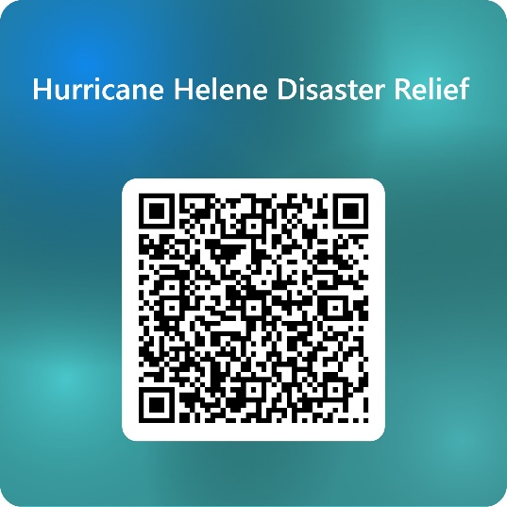**If you have been displaced due to Hurricane Helene, please use this QR code to let the RCSS Student Services team know that you need assistance. A school district representative will be in contact with you.**

If you are a family who is now displaced from their home due to Hurricane Helene you may now qualify as a McKinney Vento Student (homeless). McKinney Vento Students have the following rights:

* 1. The right to **immediate enrollment**—even without the required documents. All students should be enrolled in school the day they register.
  2. The right to **remain at their school of origin—**regardless of your nighttime residence. Students should not be forced to transfer to another school—unless the parent determines it is in the best interest of the student.
  3. The right to **request transportation to their school of origin** if that is what is in the best interest of the student. This transportation could take up to 10-14 days to set up.
  4. The right to **comparable services** (transportation, meals, and special education services) as all other students
  5. The right to **academic support** if needed
  6. The right to the **same school environment** as all other students.

**Food and Water and Supplies**

* Southgate Shopping Center 1631 Gordon Highway
* October 7, 2024 – October 11, 2024 – hot meals available from 10 am – 3 pm at the following schools:

Glenn Hills Middle--2941 Glenn Hills Drive

Hephzibah Elementary--2542 Highway 88

McBean Elementary—1165 Hephzibah McBean Road

Hornsby Elementary—310 Kentucky Ave

* Augusta Fire Department—serving free meals at Kroc Center—1833 Broad Street at 4 pm.

HUB—631 Chafee Ave at 4 pm

Center of Hope—1384 Greene Street @5:30 pm

* Warren Church—3202 Washington Road—food, ice, water, and other supplies at 10 am
* Resource Pantry at the Hub—631 Chafee Ave from 10 am- 4 pm
* Greater Augusta Interfaith Coalition –food and supplies 12 pm – 4 pm at 1439 Walton Way until October 15,2024
* Trinity on the Hill—1330 Monte Sano Ave from October 7, 2024 – October 11, 2024 11 am – 2 pm food, formula, wipes, baby food, diapers, pull-ups, cleaning supplies.

**Shelter**

* Henry Brigham Community Center
* Center of Hope—1384 Green Street

**Showers/Charging Stations/Wi-Fi**

* Augusta South, Burke, Wilson, and Thomson YMCA’s open to the public with access to showers, charging stations, water and wi-fi.

**Counseling/Student Support**

* All Schools have School Counselors that can assist with students who are having difficulty dealing with the trauma and aftermath of Hurricane Helene.
* Mental Health Counselors, School Psychologists, School Social Workers will all be available at the schools beginning on October 16, 2024 to help address those students who need more support.